Q1:

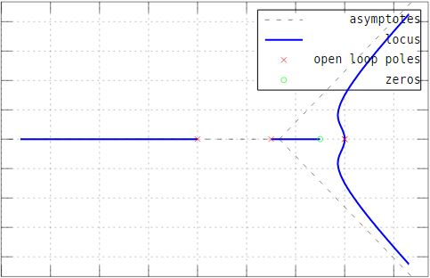

Range of k for stability = [0 to 527.51]

Code :

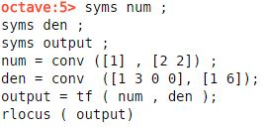

Q2:

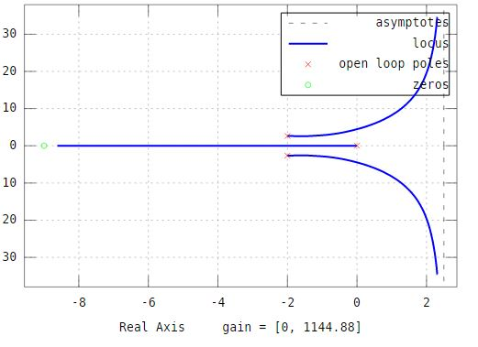

Poles = -1.51 +2.6 i and -1.51 – 2.6 i

K = 0.988

Code

Syms num;

Syms den;

Syms output;

num = conv ([1] , [1 9]);

den = conv ([1 0] , [1 4 11]) ;

output = tf ( num , den) ;

rlocus ( output)

Q3 :  
value of a = 4/7  
value of k = 7/3  
  
root locus of the system & controller   
  
Code :  
  
syms num ;

syms den ;

syms output ;

num = ([7/3 11/3 4/3]);

den = ([1 7/3 14/3 4/3]);

system = tf (num , den) ;

rlocus (system)

before controller :  
  
code  
  
syms num ;

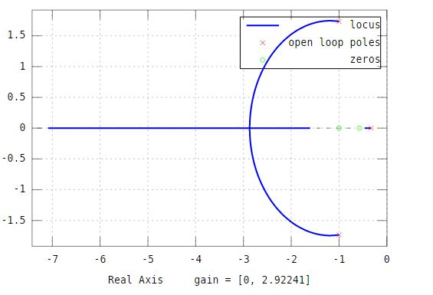

syms den ;

syms g ;

syms h;

syms t ;

num = 1;

den = [1 0 1];

g = tf (num , den) ;

h=1 ;

t = feedback (g,h)

step (t)

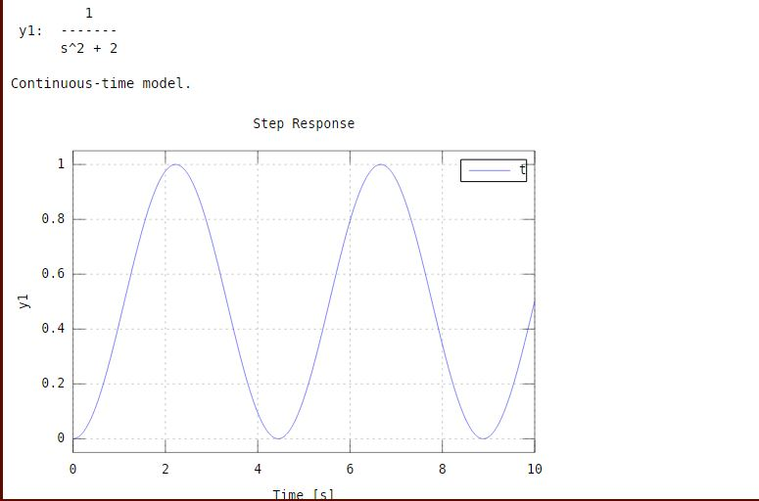

with controller :  
syms num ;

syms den ;

syms g ;

syms h;

syms t ;

num = conv([7/3 7/3],[1 4/7]);

den = conv([1 0],[1 0 1]);

g = tf (num , den) ;

h=1 ;

t = feedback (g,h)

step (t)

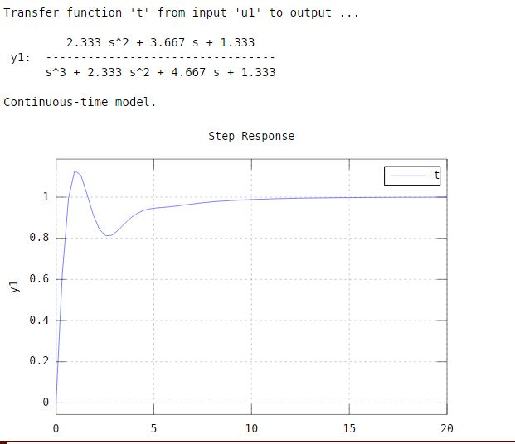

q4:  
  
angle

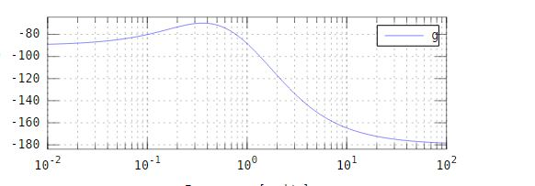

so at -140 Wc= 3.58 k = 133.01

